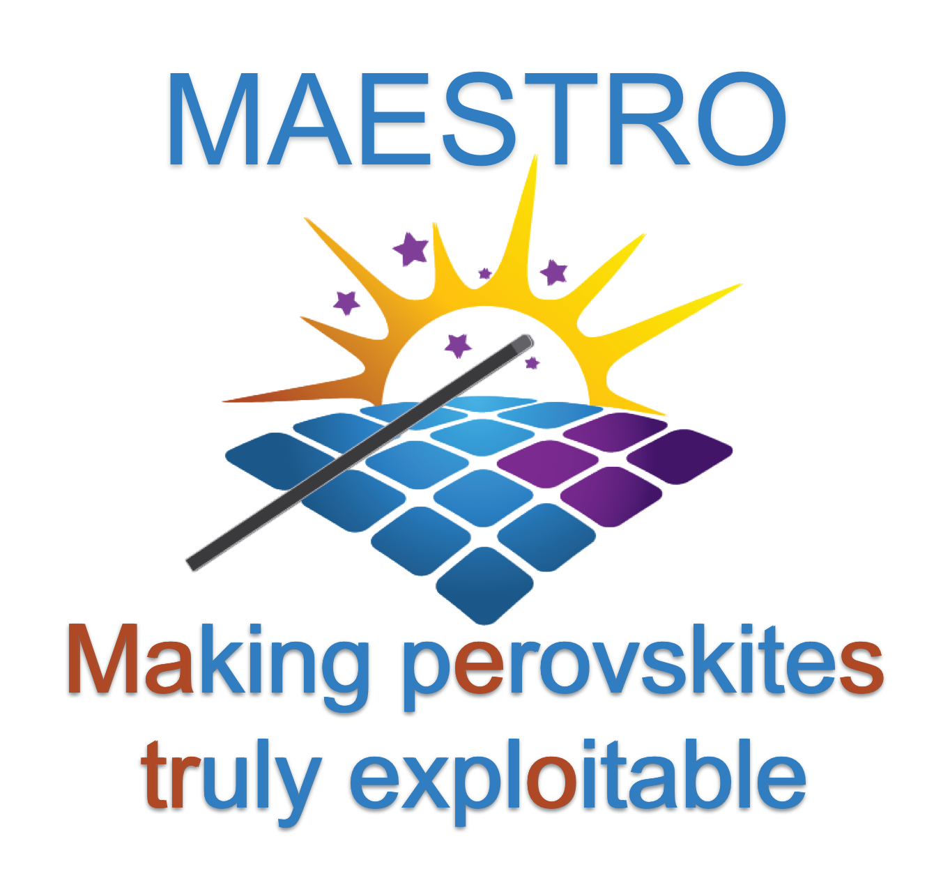

GUIDE FOR APPLICANTS



This Innovative Training Network, ITN, has received funding from the European Union’s Horizon 2020 research and innovation programme under the Marie Skłodowska-Curie grant agreement No 764787

Table of Contents
1. The ITN Maestro 2
1.1 The research and training programme 2
1.2 The participants 2
2. Call for Applicants 3
2.1 Reasons for applying 3
2.2 Available Positions 3
2.3 Who can apply? 3
2.4 Working conditions and salary 4

The ITN Maestro
Supported by the European Commission through the Horizon 2020 Marie Sklodowska- Curie ITN Programme, the Maestro European Training Network provides 15 PhD positions. These positions will be advertised by each host institution starting September 2017.

Maestro aims to attract qualified international Early Stage Researchers for high quality PhD training. The aim of the programme is to increase the international, intersectoral and interdisciplinary mobility of researchers, in line with the principles of the European Charter and Code for Researchers, and specifically the Code of Conduct for Recruitment. The most talented and motivated students will be selected for a 3-year advanced multidisciplinary research training, starting between 1 November 2017 and 1 November 2018..

The research and training programme
Maestro focusses on perovskite semiconductors, a material shown in the last 4 years to have a major impact on solar power and potentially also in display technology. Our research aims to make perovskite based devices commercially viable.

MAESTRO offers broad skills development and experience of cross sector research to 15 Early Stage Researchers, ESRs. Training is provided in (i) science and technology across physics, chemistry, materials science, electrical engineering, in two major application areas, solar cells and light emitting diodes, and other uses such as lasers and photodiodes; (ii) exploitation from laboratory to fabrication; (iii) transferable skills of communication, information technology, organization, planning, teamwork, leadership; (iv) skills needed for innovation, such as understanding markets, product life cycles, business models, return on investment. Gender aspects are addressed through supervisors, mentors and training. The research undertaken by MAESTRO will teach the ESRs how to deal with complexities and uncertainties, making them very broad and highly adaptable. Their PhDs will position them to be comfortable in both corporate and academic worlds. They will be able to seek careers that are rewarding professionally and financially, through career paths in self-employment, finance, consultancy, contracting, engineering, computer science, production

The participants
Selected researchers will enrol in one of the 15 positions offered by the 15 host organizations participating in Maestro
1. University of Bath (Coordinator) UK
2. Fondazione Istituto Italiano Di Tecnologia Italy
3. Universitat Jaume I De Castellon Spain
4. University of Oxford UK
5. National Center for Scientific Research Greece
6. Universita Degli Studi Di Roma Tor Vergata Italy
7. Bar Ilan University Israel
8. Swansea University UK
9. Universitat Konstanz Germany
10. Ecole Polytechnique Federale De Lausanne Switzerland
11. Oxford Photovoltaics Ltd UK
12. 3GSolar Photovoltaics Ltd Israel
13. Greatcell Solar UK Ltd UK
14.Uab Modernios E-Technologijos Lithuania
15. Saule Sp Zoo Poland

Partner Organizations
16. Tibercad Italy
17. National Physical Laboratory UK

2. Call for Applicants

2.1 Reasons for applying
- You will participate in specially developed courses (e.g. on specific techniques, soft skills, etc.) in many of the host countries
- From the outset, you can start building networks inside the network given the large number of academic and industrial participants and outside the network at conferences and summer schools
- There are seven partners from industry in our network who contribute to the training and research so you will see the challenges of working in industry
- You will spend some time in the labs of other partners through secondments lasting two months or more. Through this means you will acquire familiarity with other disciplines, techniques, cultures etc. as the research projects are designed such that they have interdisciplinary components
- You will be advised by excellent group leaders – they are all outstanding in their research and training

2.2 Available Positions
This list will be updated as new positions become available and the listed positions are filled.
Fabrication and characterization of large area PSC modules
Universita Degli Studi Di Roma Tor Vergata Italy

2.3 Who can apply?
Above all we are looking for enthusiasm and commitment to research in a mixed academic/ industrial environment and the undergraduate degree training that will allow you to participate fully in the lively environment Maestro offers.

We are looking for candidates who satisfy the following Eligibility Criteria
- An educational background in the area chemistry, physics, material sciences, electrical engineering or combinations thereof.
- At the level of an Early Stage Researcher. This means they must, at the date of recruitment by the host institution, be in the first four years (full-time equivalent research experience) of their research careers and have not been awarded a doctoral degree.
- They comply with the European Commission’s mobility rule (see below).
- They have excellent proficiency in English
- They satisfy any additional criteria specified by the recruiting organisation.

Full-Time Equivalent Research Experience is measured from the date when the you obtained the degree entitling you to embark on a doctorate (either in the country in which the degree was obtained or in the country in which you are recruited or seconded), even if a doctorate was never started or envisaged. Part-time research experience will be counted pro-rata.
Mobility Rule
Researchers must not have resided or carried out their main activity (work, studies, etc.) in the country of the recruiting beneficiary for more than 12 months in the 3 years immediately before the recruitment date. Compulsory national service, short stays such as holidays, and time spent as part of a procedure for obtaining refugee status under the Geneva Convention1 are not taken into account. For international European interest organisations or international organisations, recruited researchers must not have spent more than 12 months in the 3 years immediately before the recruitment date at the same appointing organisation.

Time of recruitment is defined as the date when you have been first offered the position by a representative of the host organization. This offer will need to be comply with the official selection and evaluation procedure. Also, the offer will still need to be officially ratified by the Scientific Board and officially accepted by the decision-making authority of your host organization (e.g. Graduate School, Dean or Director).

2.4 Working conditions and salary
Marie Sklodowska Curie Actions (MSCA) offer highly competitive and attractive salary and working conditions. These are as follows.
- Maestro ESRs will have a fulltime employment contract for the duration of 36 months.
- He/she will receive a salary in accordance with the MSCA regulations for early stage researchers. The basic gross salary (living allowance) is €3110 per month.
- A correction factor will be applied per country, therefore the exact gross salary will be confirmed upon appointment. The net salary may be 20-30% lower due to taxes, social benefit premiums etc.
- In addition to the living allowance, ESRs will benefit from a gross mobility allowance of €600 per month.
- ESRs who have a family at the time of recruitment qualify for an additional family allowance of €500 per month. ‘Family’ means persons linked to the researcher by marriage (or a relationship with equivalent status to a marriage recognised by the legislation of the country where this relationship was formalised) or dependent children who are being maintained by the researcher.
- ESRs will enjoy at least the same standards and working conditions as those applicable to local researchers at the host institution holding a similar position.

ESRs shall be given contracts by the host organization who recruits them. All ESRs will be registered at a university. ESRs recruited by the industrial partners shall be registered by a partner university.

2.7 Content and submission of your application
To submit your application, please fill in the requested data in the online application form provided in the advertisement for the position, upload your application file and submit your application.

Important! Please Ensure A Gender-Neutral Application
To facilitate a first gender-neutral ranking, all applications need to be fully gender-neutral. This means that – in your documents – all references to given names and gender have to be avoided or hidden. For the pre-selection, your name and gender will be hidden from the review panel to ensure a gender-neutral ranking in compliance with European Commission guidelines.

Your application should consist of the following documents, in the following order:
1. A complete Curriculum Vitae including a statement of where you have resided in chronological order, starting from 1 June 2014 and ending with the application deadline, to ensure compliance with the Mobility rule (section 2.3).
2. A copy of your Master certificate (if you have not graduated yet, please provide a copy of
your Bachelor certificate)
3. A copy of your grades (if you have not graduated yet, please include Bachelor grades and
available grades for your Master and the expected date of your degree being awarded). Please keep in mind that you need to have obtained your degree before the time of recruitment (see paragraph 2.3 for definition of time of recruitment)
4. A motivation letter (max. 800 words)
5. Summary of your research experience (max. 1 A4)
6. Copy of TOEFL or IELTS scores, if required by the recruiting institution
7. Names and contact details of two referees. The selection panel may contact them for references. Please inform your referees on the possibility of them being contacted regarding your application

3. Selection & Evaluation Procedure
Selection will be on a competitive and meritocratic basis.

3.1 Eligibility check
All applications will be checked according to the Eligibility Criteria listed in section 2.3

Ineligible applicants will receive a rejection notification stating the reason(s) for their ineligibility and the possibility for redress within 2 weeks after submission of their application.

Each application will be ranked by at least 3 evaluators:
1. The supervisor(s) of the project(s) the applicant has applied for (1 or 2) 2. One domain specialist (1)
3. Another supervisor in the consortium
We will strive for a balance between academic/non-academic, senior/junior and male/female evaluators as much as possible. Evaluators need to be free of any conflict of interest, e.g. romantic or family relations, economic benefits, emotional life et cetera.

Shortlisted candidates will be interviewed for each position through teleconferencing by a selection panel composed of the main supervisor and two domain specialists (of which preferably a balance between academic/non-academic, male/female scientists and junior/senior scientists).

